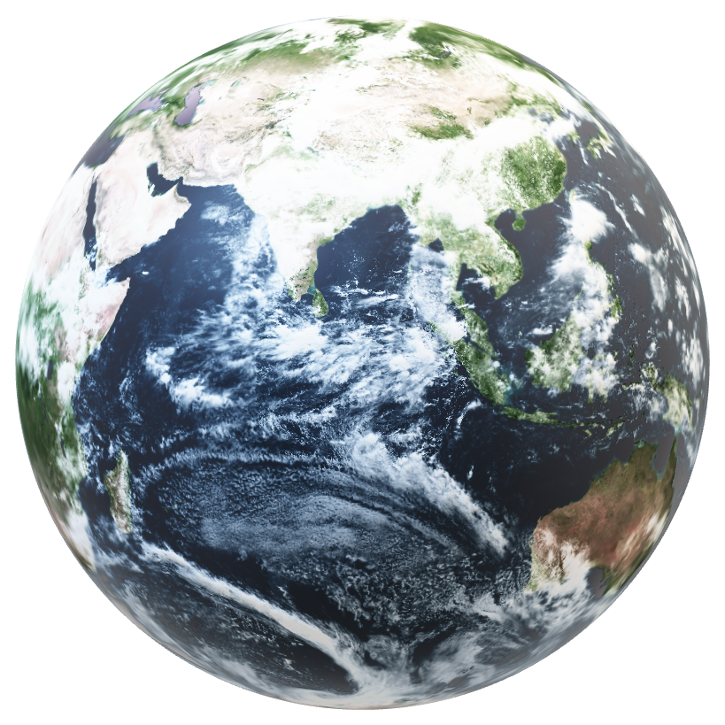

**Wate**

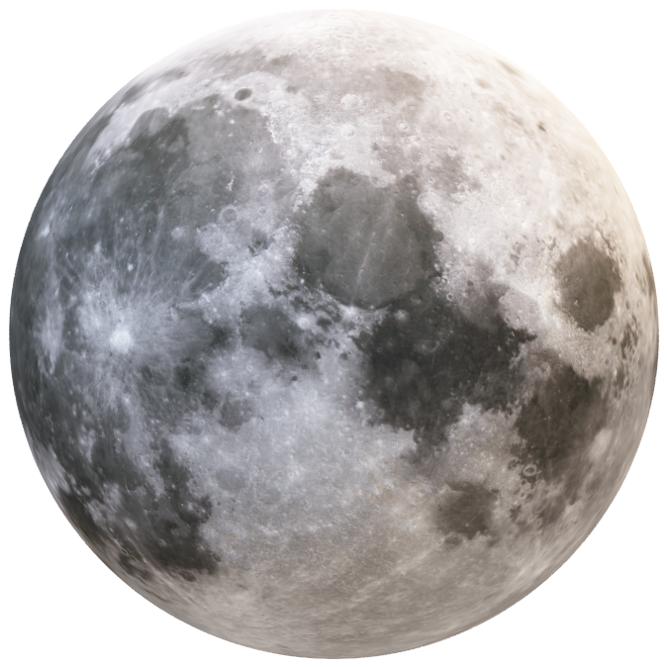

**TABLE OF CONTENTS**

**TEAM** 3

**INTRODUCTION** 4

PROJECT 4

**IMPLEMENTATION** 5

COMMUNICATION 5

PROGRAM APPLICATIONS 5

BLOCK SCHEME 6

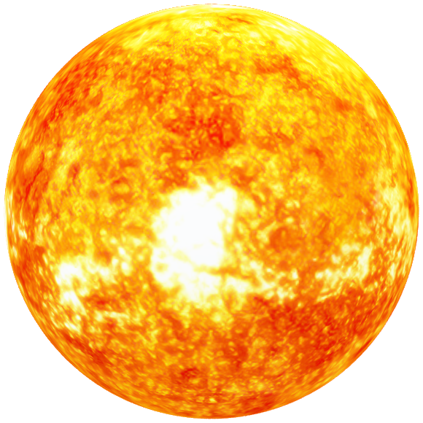

# **TEAM**

**Scrum Trainer**

Kalina Atanasova – 9V

**Front-End Developer**

Iva Raykova – 9G

**Back-End Developer**

Kaloyan Iliev – 9G

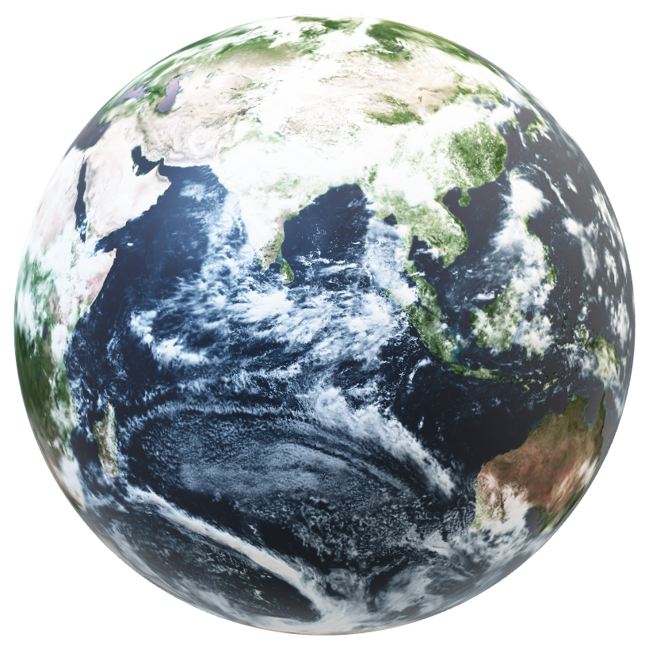**Designer**

Natali Ribareva – 9V

# **INTRODUCTION**

## PROJECT

The project is about creating innovative solutions for global warming, pollution and the importance of taking care of the nature. The specific content and purpose of the website is by the team. The languages we used are HTML, CSS and JavaScript

# Earth**IMPLEMENTATION**COMMUNICATION

Our communication went through Discord and partially through Microsoft Teams

# PROGRAM APPLICATIONS

We used Visual Studio Code for website development, Figma for design collaboration, Microsoft Windows for documentation, and Photoshop for image editing. Our presentations were crafted using Microsoft PowerPoint, ensuring a cohesive and professional project showcase.

**BLOCK SCHEME**